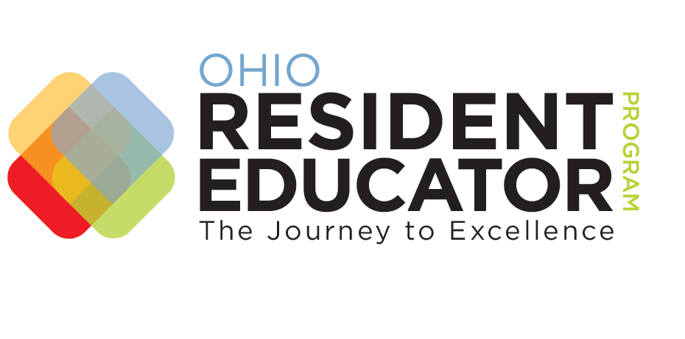
Resident Educator Year 2 Formative Progress Review Template

Resident Educator: Mentor: Program Coordinator: Date:
PURPOSE The Year 2 Formative Progress Review provides an opportunity for Resident Educators (RE), mentors and program coordinators to synthesize evidence of practice, reflect on communication and professional growth, and assess REs’ readiness to prepare for and take the Resident Educator Summative Assessment in Year 3.

NOTE Before beginning the Year 2 FPR, REs and mentors should carefully read all prompts. Note that the optional Prompt # 2 (lesson analysis) is part of the required Prompt # 1 (instructional cycle). Therefore, if REs choose to complete Prompt # 2, they will need to plan for videotaping the lesson in advance of teaching the lesson.

Role | PROMPT # 1: INSTRUCTIONAL CYCLE (REQUIRED)
RE | This prompt requires REs to demonstrate an understanding of the connections among processes used within an instructional cycle.  Identify an instructional cycle and one lesson from that cycle that you are teaching or have taught this year. Respond to the questions below in 3-5 double-spaced pages.  - List the student learning outcomes for the instructional cycle and for the lesson.  - Explain how the learning outcomes for the lesson and the instructional cycle are connected.  - Describe how the instructional strategies you used in the lesson helped students link their prior learning to new learning.  - Identify 2 students in your class who represent 2 different performance levels. Describe how you formatively assessed the progress of each of those 2 students toward achieving the learning outcomes for the lesson. Include at least one student work sample or artifact from each student as evidence of his/her learning. (The student work samples or artifacts do not count as part of the 3 – 5 page response.)  - Summarize the results of the formative assessment for each of the 2 students in the lesson. You may do this using a chart, table, graph, narrative text, or a combination thereof.  - Describe how you summatively assessed the progress of the 2 students toward the learning outcomes of the lesson. (This summative assessment may also represent the summative assessment you used for the entire class.)

PROMPT # 2: LESSON ANALYSIS (OPTIONAL)
Role
RE | This prompt provides REs with the opportunity to engage in further analysis of their teaching by arranging to videotape and analyze a lesson from the instructional cycle.  Before videotaping, REs must obtain appropriate permission (per their district or school policy) from students’ parents or guardians and from any adults who appear in the video. REs may adjust the camera angle to exclude individuals who did not grant videotaping permission.  Videotape a lesson from your instructional cycle in Prompt # 1. Analyze a 15-20 minute segment of the lesson by reviewing it and responding to the questions below in 3-5 double spaced pages.  - How did you communicate the student learning outcomes for this lesson to the students?  - Using the student learning outcomes as a measure, on what skills and understandings did students perform well? For which do they need more instruction or practice?  - Identify at least 2 segments in the video in which you demonstrate mutual respect for and rapport with all students.  - Describe the feedback you provided to all students during the lesson.  - What opportunities did you provide to students during the lesson to respond to your feedback?  - Based on your formative assessment of all students’ progress, how did you modify or differentiate instruction in that lesson  or in future lessons within the instructional cycle?  - Explain how the lesson reflected academic rigor and required all students to demonstrate higher-order thinking skills.
PROMPT # 3: COMMUNICATION (REQUIRED)
Role
RE |  |  | This prompt requires REs to describe their use of communication to form partnerships with families and caregivers to support student learning.  Provide 2 - 3 communication strategies you used to enhance family and caregivers’ understanding of their child’s learning goals and their child’s progression toward those goals.  - Describe the communication strategies you used.  - Explain why you chose the strategies. You may wish to include how feedback you received from families and caregivers informed the strategies you used.  - Describe how the strategies provided opportunities for family and caregiver involvement and how they supported student learning.
PROMPT # 4: PROFESSIONAL GROWTH & COLLABORATION (REQUIRED)
Role
RE | This prompt requires REs to explain how they have engaged in professional development and collaboration to enhance their instructional practice.  Describe two relevant examples of job-embedded professional development you have participated in within the past two years. Include a description of the new learning you experienced as a result of the collaboration and how you applied the new learning in your classroom. You may include collaboration with your mentor as one example. To respond to this question, you may choose to compose a narrative in 1 – 2 double spaced typed pages or complete the chart below.  Description of Collaboration Activity Purpose of Collaboration Description of New Learning and Application of New Learning in the Classroom
RE |  | Please check the box if all Year 2 Resident Educator Program tools and processes have been completed.
PROMPT # 1: COLLABORATIVE INQUIRY (REQUIRED)
Role
Mentor |  |  |  | This prompt requires mentors to develop questions for the RE that engage him/her into deeper analysis of his/her responses to the FPR prompts. Mentors may create questions of their own or use the suggested question stems provided in the text box below.  Review the RE’s responses to the prompts to which he/she has responded. Then, develop one question for each statement below (for a total of 3 - 4 questions) that you will ask in a follow-up collaborative conversation with the RE that will allow him/her to demonstrate understanding of the following practices:  - Instructional Cycle Reflection (Prompt # 1): The relationship among student learning outcomes, instructional strategies, and summative assessment in an instructional cycle  - Lesson Analysis (Prompt # 2 – if chosen by the RE): The relationship among student learning outcomes, formative assessment of student progress, and feedback in a lesson analysis  - Communication (Prompt # 3): The relationship among communication strategies, family/caregiver engagement, and support of student learning  - Professional Growth and Collaboration (Prompt # 4): The relationship among professional development, new learning, and change in teaching practice  Suggested Question Stems  Tell me what you mean when you...? To what extent…?  What’s another way you might…? What would it look like if…?  How was…different from…? How did you decide…?  What criteria did you use to…? What impact do you think…?  What might you see happening in your classroom if…?
Mentor |  |  |  | Please check the box if all Year 2 Resident Educator Program tools and processes have been completed.

