Silk Road Civilizations Activity

Passport
For
___________________
The
Silkworm

Guardian
Name_____________________
Period___________________
October 29-31, 2012
Station 1
Silkworms at work
Complete each of the following activities in the space provided.
Lab Station
Observe the Silkworm under the dissecting microscope. Watch it feed. Touch it gently with the blunt metal probe.
In the box below, list 5 detailed observations of your silk worm.

Draw and label your silkworm as it appears under the dissecting microscope.

Describe how your Silkworm feeds. Give 3 details.

Describe how your Silkworm responds to light, gentle touch with the blunt probe.

Check out this website:
http://www.enchantedlearning.com/paint/subjects/butterfly/activities/printouts/silkworm.shtml
Read the information and use the interactive paint to color your Silkworm.

Write two new facts you learned about Silkworms:
Fact 1.
________________________________________________________________________________________________________
Fact 2.
________________________________________________________________________________________________________
Station 2
Mosaics on the Silk Road
History of Mosaics
http://www.aquilomosaics.com/a_brief_history_of_mosaic_a.html
History of Mosaics for kids from the BBC
http://www.aquilomosaics.com/a_brief_history_of_mosaic_a.html

First look at the history of Mosaics then begin your own Mosaic.
Choose one of the patterns and make a mosaic using the sticky-backed foam tile pieces.
Cut the larger pieces into smaller squares. Notice that the large mosaics were using squares that were ½ inch or smaller. So cut yours into 1/8 to ¼ inch sizes. Only use what you need.

Something extra:
When you are finished you can make a mosaic on the website and then print it off as well.
Make a Mosaic online
http://gwydir.demon.co.uk/jo/mosaic/index.htm

Station 3
Music of the Silk Road
http://www.silkroadproject.org/
http://www.silkroadproject.org/tabid/445/default.aspx
World famous cellist, Yo-Yo-Ma and the Silk Road Ensemble have made people from around the world aware of the beauty and culture of the Silk Road civilizations through concerts of their music. These have taken place in New York City, Millennium Park in Chicago, London, and Shanghai.
Music of the Silk Road takes on the characteristics, rhythms, and tone scale of the peoples of the area.
Listen to three of four of the music selections to introduce yourself to the music of that section of the Silk Road.
1. Name of the Music selection _________________________________
Where is it from: _____________________________________________
What instruments do you recognize?
________________________________________________________________________________________________________
Describe one instrument you did not recognize:
________________________________________________________________________________________________________
Describe the cadence or rhythm of the music:
____________________________________________________________________________________________________________________________________________________________

2. Name of the Music selection _________________________________
Where is it from: _____________________________________________
What instruments do you recognize?
________________________________________________________________________________________________________
Describe one instrument you did not recognize:
________________________________________________________________________________________________________
Describe the cadence or rhythm of the music:
____________________________________________________________________________________________________________________________________________________________

3. Name of the Music selection _________________________________
Where is it from: _____________________________________________
What instruments do you recognize?
________________________________________________________________________________________________________
Describe one instrument you did not recognize:
________________________________________________________________________________________________________
Describe the cadence or rhythm of the music:
________________________________________________________________________________________________________
Station 4
Silk Road Activities
The Virtual Labs Project at Stanford
http://virtuallabs.stanford.edu/silkroad/SilkRoad.html
Stanford University has prepared maps, timelines, music, and sights along the Silk Road for you to explore. Read, interact, and explore using this website to expand your knowledge of the Silk Road.
Map Activity: Choose two different maps and compare their influences on the region. Show how cultural diffusion has helped or been stopped by natural or human barriers.
1.______________________________________________________________________________________________________________________________________________________________________________________________________________________________________________

2.______________________________________________________________________________________________________________________________________________________________________________________________________________________________________________

Timeline Activity: Choose two of the entries on the timeline and describe what made you choose them. It could be about the art, the action, the name of the person involved.
1.______________________________________________________________________________________________________________________________________________________________________________________________________________________________________________

2.______________________________________________________________________________________________________________________________________________________________________________________________________________________________________________

Sights along the Silk Road Activity: Choose two of the sights along the Silk Road that you enjoy. Explain what they mean to you in our modern day.
- ________________________________________________________________________________________________________________________________________________________________________________________________________

- ________________________________________________________________________________________________________________________________________________________________________________________________________

Music of the Silk Road Activity: Explore the information given on the Music of the Silk Road. Write about two instruments or areas of music that interest you.
- ________________________________________________________________________________________________________________________________________________________________________________________________________

- ________________________________________________________________________________________________________________________________________________________________________________________________________

Station 5
Timeline Activity
It is exciting that the Silk Road was in existence for hundreds if not thousands of years. It covered much of the planet both in time and distance. With a wealth of history available in so many civilizations, and then empires, and countries specific events and people are easy to find on the Silk Road.
Find one fact from any area along the Silk Road that interests you. It can be about a person an event or a building or a battle. Write about that chosen fact in your own words and what it means to you. Make the margins about 6 inches wide so it can be easily put on a big timeline roll. Select and paste a picture into your caption. Then cut it out and paste it to the colored paper that corresponds with the civilization designated for that fact.
Finally paste your information and picture onto the timeline..
Greece- Blue
Rome – Red
China – Green
Mongols – purple
Japan – Yellow
Persia – Pink
India – Purple
Africa – Beige

Station 6
Genghis Kahn Activity
This is a video on the life, work and death of Genghis Kahn. In the days of Genghis Kahn there was much strife and fighting among the tribes in Mongolia. Even though they were fierce warriors they spent their time fighting each other instead of expanding the territory of Mongolia. Genghis Khan changed all of that and united all of the tribes.
You will be watching the 20 minutes section of this video that shows the young Genghis coming to the realization that to become a great empire they had to unite. You will see that there were some tribes that were looked down upon.
After you watch the video, write 3 observations about what you saw.
- _________________________________________________________________________________________________________________________________________________________________________________
- _________________________________________________________________________________________________________________________________________________________________________________
- _________________________________________________________________________________________________________________________________________________________________________________

Write a short reflection on how this relates to what goes on today.
________________________________________________________________________________________________________________________________________________________________________________________________________________________________________________________________

Station 7
Math and Map Activity
Exploring Map Skills
The ability to read and use maps is an important area within the social studies curriculum. Working with maps provides a mathematical opportunity to discuss the use of legends or keys and to discuss the difference in distance as the “crow flies” versus distance along a road.
The very beginning of the The Silk Route features a map of The Silk Route. This map is a simple form that is not cluttered with extra information that would be provided in most general maps of the region. The route winds from city to city like a red and gold snake. In finding the distance between cities, students might be tempted simply to count the number of red and gold segments on the route. However, on a closer inspection they will find that the segments are not of equal size across the entire map; thus, they need to use the distance key provided. It is interesting to note that distance is provided in both kilometers and miles.
After reading The Silk Route to a class, the teacher might challenge students to check the distance from Chang’an in China to Byzantium. If students are going to check the claim of the author then they need to be sure to use the miles key. (Note: the scale is 500 miles per inch.)
1, Students are to place a string on the map to closely follow the silk route indicated on the map, measure the length of the string, and then multiply their length in inches by 500 miles per inch. Such an activity is great for small groups because it helps to have several fingers to place the string on the route on the map.

- Students are to find the distance between each of the cities mentioned in the story.
From | To | Distance Between the cities in inches | Distance in Miles
Answers:
Chang'a n | Dunhuang | __________________________ | ___________________ | (1300) [1200]
Dunhuang | Kashgar | ____________________________ | ___________________ | (1500)
[1300]
Kashgar | Tashkent | ____________________________ | ___________________ | (800) [700]
Tashkent | Heret | ____________________________ | ___________________ | (900) [800]
Heret | Baghdad | ____________________________ | ___________________ | (1300)
[1100]
Baghdad | Damascus | ____________________________ | ___________________ | (400) [400]
Damascus | Tyre | ____________________________ | ___________________ | (200) [200]
Tyre | Byzantium | ____________________________ | ___________________ | (1400)
[1400]
 | TOTAL | ____________________________ | ____________________ | (8000)
[7000]
(Note: the distance between cities varies depending on the measured distance along the route on the map or the straight-line distance between the mentioned cities. Our estimates for actual map or curved paths are indicated in parentheses and the corresponding straight-line distances are enclosed in brackets. Which do you suppose the author used? How can you support that claim?)
Modes and Speed of Travel
Considering the differences in modes and speeds of travel provides another opportunity to integrate discussion of cultural differences and history and computational work in mathematics. The following activities suggest some ways to integrate social studies and mathematics. These activities are appropriate for upper elementary or middle grades students, depending on their mathematical background; teachers can easily adapt activities by modifying the numbers used.
At the end of the story, the author provided additional information about the places and modes of travel. He indicated that a caravan might travel as few as 10 miles per day or as many as 50 miles per day, depending on the terrain and weather conditions.

Choose one of these examples and work it out together
Include your worksheet for this part of the Activity.
Example 1.
Suppose you are a private Chinese merchant who is making the trip as far as Kashgar. It is important to get to Kashgar and back as far as Dunhuang before the summer heat makes crossing the Taklamakan Desert too dangerous. To be safe you decide that the trip must be completed by June 1. If the reliable guides claim that you can average 30 miles per day, when would be the latest that you could leave Chang’an with confidence that you would make it according to your ideal time schedule?
Explain how you decided on the date on which to leave with the caravan.

Example 2.
Suppose that you are traveling west with a load of fine silk. At Dunhuang, your caravan guide informs you that you must pack at least 8 liters of water per day for the trip across the desert. Your camel can carry an additional 70 kilograms. Will you have to get an additional camel to transport the needed water? Explain your answer.
Example 3.
After carefully listening to stories from older merchants you have determined that the value of fine silk increases by 50% for each 1000 miles it is moved to the west. Further you determine that fine rugs from Baghdad increase the same amount for each 1000 miles they are transported to the east. You determine to make the trip from Chang’an to Baghdad with a load of silk. After arriving in Baghdad you plan to trade the silk for Persian rugs, which you will sell back in China. If you leave with $1000 worth of silk, what value should you have upon trading in Baghdad?
[ Hint: use the miles between cities figured earlier (about 6000 miles).]

Example 4.
A rival merchant from Chang’an also has plans to trade silk for Persian rugs, but the rival is only going as far as Kashgar. There the rival will sell the silk and buy the rugs for later sale in Chang’an. The rival will not make as much money, but believes that he can make two such trips while you make only one. If the rival actually can make the two trips to your longer one, who will have the greater profit from the business (assume the expenses of caravan travel are the same for your one trip and for the rival’s two trips)?
Changes Over Time
Students often fail to realize that cities may change names over time, depending on various historical actions such as war and occupation by other countries. Exploring such changes provides another opportunity to integrate mathematics and social studies, along with technology through exploration via reference books or the Internet.
For the next exercise students investigate which cities mentioned in the Silk Route have had name changes since 700 AD. For example, Byzantium changed to Constantinople and is now Istanbul. However, Damascus, Baghdad, Tyre and Dunhung are still called by the same names. What kind of reference book could be investigated to check on city names?
Example 5.
Using a current map, plot a route that passes through the cities mentioned in the story from Chang’an (now Xi’an) to Tyre. Then approximate how long it would take to travel that route by truck if the driver actually drives for 10 hours per day and can average 50 miles per hour (assume that there are no problems passing from one country to another). (Answer: 12 days) How much would it cost if you hire a truck driver at a rate of 55 cents per mile? The driver pays for the fuel at a rate of 75 cents per liter. If the truck can average 8 miles per liter of fuel how much will the driver make for the entire trip?
Example 6.
If the truck driver had to have his/her passport stamped at each border crossing how many times would the truck driver have had his/her passport stamped?
Conclusion
The ideas discussed here are just a few of the ideas that tie mathematics with a story of early commerce between two major civilizations, Chinese and Persian of the late first millennium, that are not often featured in the social studies curriculum. The focus here was on mathematical tasks. The Silk Route offers a treasure of other possible activities and investigations.

Station 8
Marco Polo and the Silk Road
http://zunal.com/webquest.php?w=133281

This entry is a webquest designed to introduce the legendary Marco Polo to those seeking information about him and his adventures on the Silk Road.
Use the Marco Polo section of the webquest to find information needed. There are four (4) sources of information to use.
Where was Marco polo born? _________________ When? ____________
Name four places where Marco Polo went and what he accomplished there:
Place___________________________________
1._________________________________________________________________________________________________________________________________________________________________________________________________________________________
Place___________________________________
2._________________________________________________________________________________________________________________________________________________________________________________________________________________________
Place___________________________________
3._________________________________________________________________________________________________________________________________________________________________________________________________________________________
Place___________________________________
4._________________________________________________________________________________________________________________________________________________________________________________________________________________________

What was the purpose of the travels of the Polo family?
________________________________________________________________________________________________________________________________________________________________________________________________________________________________________________________________
Draw a map of Marco Polo’s travels. Use color to show different areas and countries.

What do you think was the significance of Marco Polo’s journey?
________________________________________________________________________________________________________________________________________________________________________________________________
Why do we have a record of Marco Polo’s travels?
________________________________________________________________________________________________________________________________

Station 9
Japanese Haiku Poetry

How to Write a Haiku
http://www.wikihow.com/Write-a-Haiku-Poem
Japan eventually became a part of the Silk Road, but used sea routes to connect. Silk was highly prized in Japan.
Japan also prized the arts and poetry. Even the Samurai warriors wrote poetry. Focusing quietly on creating poems about nature and animals calmed them and helped them to channel their energies.
One form of poetry is the Haiku. It consists of 3 lines with five syllables in the first line, seven syllables in the second line, and five syllables in the last line.
The haiku is meant to be a type of meditation, a thoughtful type of writing that makes you think deeply about a season, a landscape, a type of animal and its characteristics. Oftentimes there is a contrast indicated in the poem. Two seasons, animals or conditions of being for example: life and death.
When writing a Haiku, use the senses, all five of them, to help the readers capture the feeling being written about.
How to Write a Haiku
http://www.wikihow.com/Write-a-Haiku-Poem
Look at the very simple explanation given in the KidZone page. Even though it is very simple, the ideas and form will help in writing a Haiku.
Practice writing a Haiku until you are satisfied with your work, then illustrate your poem in the style of the Japanese. You may use decorative writing or decorative but readable type choosing a font on the computer.
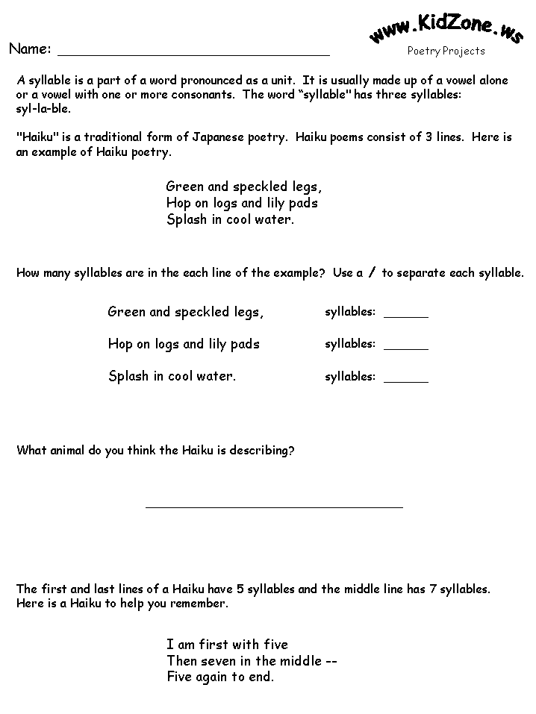
After filling in this page, begin working on your own Haiku.
Station 10
Stories of the Silk Road
Authentic stories of the Silk Road are found in the Folktales of the regions along the trails and paths of the Silk Road. These would be passed down from family to family, from grandfather to grandson and from grandmother to grand-daughter. They would also be passed from one group of people to another around companionable campfires as the journey would progress from region to region and from town.
Choose two of the stories from Stories of the Silk Road by Cherry Gilchrist to read. Then describe the character of the main character. Describe the main problem. Then re-tell how it was resolved. Finally write what was the moral of the story.
Name of the Story_________________________________________________________
What region was the story from _____________________________________________
Describe the main character ________________________________________________________________________________________________________________________________
Describe the main problem
________________________________________________________________________________________________________________________________________________________________________________________________
How is the main problem resolved
________________________________________________________________________________________________________________________________________________________________________________________________
What was the moral of the story
________________________________________________________________________________________________________________________________________________________________________________________________

Name of the Story_________________________________________________________
What region was the story from _____________________________________________
Describe the main character ________________________________________________________________________________________________________________________________
Describe the main problem
________________________________________________________________________________________________________________________________________________________________________________________________
How is the main problem resolved
________________________________________________________________________________________________________________________________________________________________________________________________
What was the moral of the story
________________________________________________________________________________________________________________________________________________________________________________________________

When you have completed the two selections, there are more folktales from China for you to read at your leisure. Choose one or two to take with you. Comment on them on the lines below.
________________________________________________________________________________________________________________________________________________________________________________________________________________________________________________________________________________________________________________________________

Station 11
Art of the Silk Road
Silk Road Seattle Virtual Art Exhibit
http://depts.washington.edu/silkroad/exhibit/index.shtml
Luxury Arts of the Silk Road Empires
http://www.asia.si.edu/exhibitions/online/luxuryarts/default.htm

The art of the Silk Road covers centuries in time and entire regions, countries and civilizations reaching from Japan to Spain and from Russia to Timbuktu in Africa. Some of these treasures are shown in these websites. Examine them, read about them, and then choose one of them to focus on as you try to reproduce it in crayon, colored pencil, marker, or paint.
Print off the original so that you have a model to use. Then write about how this object was used at the time and how it would be used today. Write about what we would use instead if we could not use that particular object.
Use the word processor for your writing.

