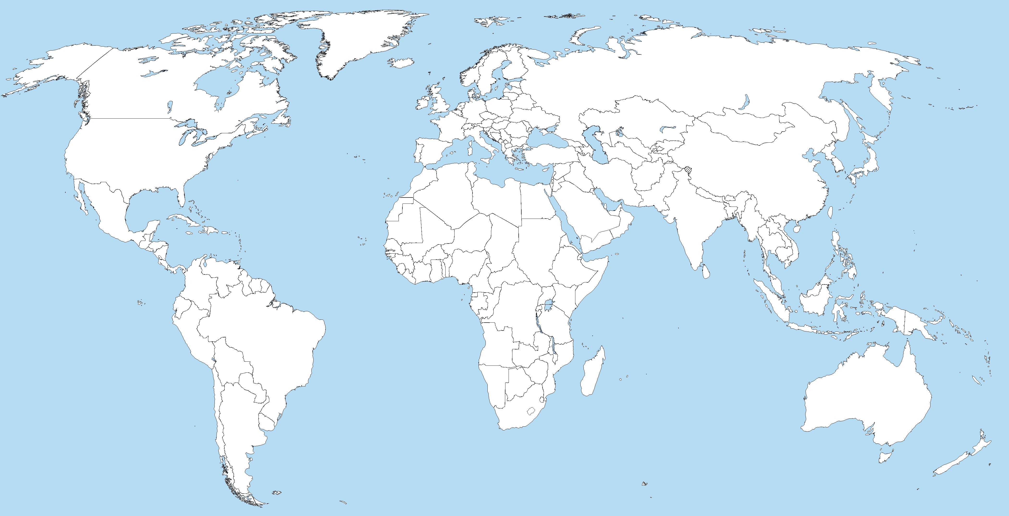

World Experience Passport

2014-2015
____________________

Passport to the World
Around You
Assignment: Go beyond the classroom! During the course of this class, you will be given some amazing opportunities to extend your learning beyond the classroom. Your job is to document these experiences.
Requirements: Be prepared to present an experience every 2 weeks. This means that you are going to complete 8 different experiences. There are reminders on the calendar about when the experiences should be completed, but there will be no formal presentation day. It is your responsibility to let us know when you are ready!

Surname: _______________________
Given Name: ____________________
Port of Origin: Room 306,
Shaker Heights High School, Shaker Heights Ohio
Date of Issue: ___________________
Expiration Date: ________________

Signature: _____________________________
Class Passport:
World Experience
Travel Date | Experience | How do you document it? | Experience Stamp
 | Eat at an ethnic restaurant.  NOTE: No chain restaurants, no Mexican, no Italian, no American. | Write a description of the experience and give a review of the restaurant. Have the waiter/waitress sign the receipt and turn it in. Bring a menu for extra credit! See the last page for a list of ethnic restaurants in our area, or find your own!
 | Watch a movie with subtitles.  NOTE: Movie must be relevant to the class in someway. | Watch the film a documentary or feature film about with subtitles. Write a movie review or create a movie poster about how the film relates to this class and what you learned (your parent must sign that you did so)
 | Interview someone born outside of the United States. | Where have they come from? What challenges have they overcome? What have they achieved? What stories do they have to tell? What do they know about you? Interview someone in your community who is from another part of the world and tell their story.
 | Watch/Read and compare a news story from an American source and a source of foreign journalism. | Document the stories (either print the hard copies of an article or provide links to video) and write a comparison that summarizes the event, the groups involved, and compares how the different news outlets treat the event.
 | Attend a festival of another culture or religion. | Take a picture of yourself in front of FIVE different cultural aspects of the festival. Then take pictures of signs, booths, etc. and put them into a slideshow to show to the class as you explain what your pictures are and mean! Research the culture enough to make connections.
 | Attend a religious service other than your own | Visit a place of worship other than you religion. Reflect on the similarities and differences between the two religions. Make a list and describe 5 things that intrigued you about the religion. Bring a flyer or take a picture of yourself outside the place. Make a presentation to your class. Research the religion enough to make connections.
 | Read a short story written by an author who is native to one of the countries from our literature this year | Complete the Short Story Analysis sheet that is posted on the English Moodle page under the “Passport Project” heading. Submit an annotated copy of the story and the handout.
 | Read a poem, written by an author who is native to one of the countries from our literature this year. | Complete the Poetry Analysis sheet that is posted on the English Moodle page under the “Passport Project” heading. Submit an annotated copy of the poem and the handout.
 | Go see a speaker who is presenting on a global topic. | Provide a brochure/ overview that is handed out at the event. List 10 things you learned from the presentation and be prepared to share this with the class. Make sure you research any unanswered questions that you had at the end of the event.
 | Attend a museum exhibit that is focused on a global topic. | Visit a museum with an exhibit relating to something global and related to the class. Create a brochure for the museum and why someone from this class should go to visit.
 | Propose an experience: | Compete the “other proposed form” and submit it to both your teachers for approval before you attempt.

