OHIO RESIDENT EDUCATOR PROGRAM
Assessment of Students
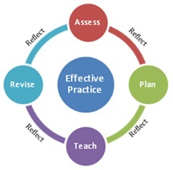
Monitoring
Student Learning

Purpose: Although Resident Educators will collect multiple sources of evidence of student learning throughout the year, this data inventory allows REs to identify a limited number of students and to monitor their learning in-depth. This process will help REs assess the effectiveness of their instructional practices. Monitoring a limited number of students can help the RE feel less overwhelmed by the range of learner needs within the classroom.

Directions:
- Together, mentors and Resident Educators identify two students from two different instructional groups.
- Resident Educators complete the Monitoring Student Learning data inventory below.
- Once the Monitoring Student Learning data inventory is complete, mentors and Resident Educators can move into the planning phase of the Teaching-Learning Cycle.
MONITORING STUDENT LEARNING
Resident Educator: |  | Date Completed:
Grade Level/Subject Area: |  | Grade Level/Subject Area:
Student Name (First Name Only) |  | Student Name (First Name Only)
Student Profile: Gender, Age |  | Student Profile: Gender, Age
Description of Learning Concerns: |  | Description of Learning Concerns:
Relevant Data | Data Source | Relevant Data | Data Source

