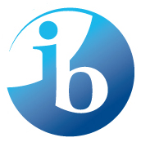
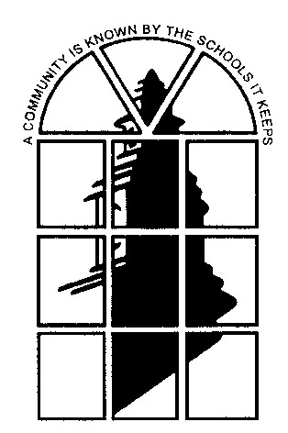INTERNATIONAL BACCALAUREATE DIPLOMA PROGRAMME

FACT SHEET

FOR STUDENTS AND PARENTS

Shaker Heights High School offers the IB Diploma Programme to juniors and seniors. IB is a rigorous, advanced, liberal arts curriculum in which students complete community service, academic coursework, and assessments, over a two year period, in six subjects; English, Mathematics, Science, History/Social Science, World Language, and the arts or an approved IB elective (a second World Language, a second Science, or a second History/Social Science).
Students can earn a Shaker IB Medallion by completing three IB courses and the IB CAS requirements or enroll in individual IB Diploma courses as well.

2-year IB Diploma Programme students will:
- Study six subjects from the curriculum model below
- Study three subjects at the Higher Level (HL) & three subjects at the Standard Level (SL)
- Write a piece of independent scholarship in a subject area of interest (the Extended Essay)
- Complete the Theory of Knowledge course which connects all of the subjects called
- Participate in Creativity, Action, and Service (CAS)
- Demonstrate ethical behavior in all areas of academics

Group 1
Language A:
English Literature

Group 3
Individuals and Society:

History
Economics

Group 2
World Language:
French
German
Latin
Mandarin
Spanish, Ab Initio
German Ab Initio

Theory of Knowledge
Extended Essay
Creativity, Action, Service (CAS)

Group 4
Science:

Chemistry
Environmental Systems and Societies
Physics

Group 5
Mathematics:
SL or HL Level

Group 6
Arts or IB Elective:
Visual Art
Digital Art
Music
or second selection from
Group 2, 3, or 4

Are you an IB Diploma student?

Do you aspire to the following? Do the following traits already describe you?

- Curious to develop a global perspective
- Enjoy learning
- A thinker, inside and outside the box
- Ability to write or willingness to develop writing skills
- Self-motivated and driven to succeed
- Works well with teachers
- Interested in an activity in or out of school
- Willingness to learn in subjects that offer a challenge
- Able to manage time effectively or aspire to acquire this skill
- Not scared of hard work & have had previous academic success in a Honors or AP class

Why do IB?
The IB…
 | is flexible and wide-ranging. The Programme meets a wide variety of student needs and interests.
2. | encourages independence as a learner. Students select their Extended Essay topics according to their interests.
3. | is not just about academic achievement but also about personal growth.
4. | offers depth and breadth in the curriculum.
5. | is excellent preparation for university.
6. | students are more successful and engaged in higher education than their peers.
7. | Is an advantage in college admissions, grants of college credit, and scholarships.
8. | is a mark of excellence and growing enterprise especially in the US.
9. | expands the mind.

Come and learn more about the IB Diploma or IB Diploma courses. Join us for one or more of the following events
IB Information Sessions for Prospective Students and Parents

October 24, 2014 | 12 PM – 1 PM | Small Auditorium SHHS
October 30, 2014 | 7 PM – 8:30 PM | Small Auditorium SHHS
January 8; 2015 | 7 PM – 8:30 PM | Small Auditorium SHHS
January 10, 2015 | 9:30 AM – 11:00 AM | Small Auditorium SHHS
January 27, 2015 | 7 PM – 8:30 PM | Small Auditorium SHHS
February 3, 2015 | 3:15 PM – 4:15 PM | IB Tea for Students – Small Auditorium SHHS

Or visit our website at http://www.shaker.org/internationalbaccalaureate4999.aspx

Questions? Please contact

Mr. Tim Mitchell
IB Diploma Coordinator
IB Office 223
mitchell_t@shaker.org
(216) 295-6257

