CCSSM: 3. NF.1: Understand a fraction 1/b as the quantity formed by 1 part when a whole is partitioned into b equal parts; understand a fraction a/b as the quantity formed by a parts of size 1/b.

Activity: Naming the Whole for a Fraction

Mr. Smith displayed the picture below on the SMART Board.
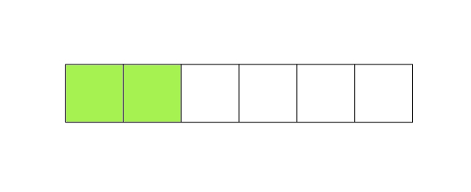

He then asked the students: What fraction does this picture represent?

- Janice said that the picture represents ²/₆. Label the picture to show how Janice’s answer can be correct.
- Kevin said that the picture represents ⅔. Label the picture to show how Kevin’s answer can be correct.
- Christina said that the picture represents 2. Label the picture to show how Christina’s answer can be correct.

