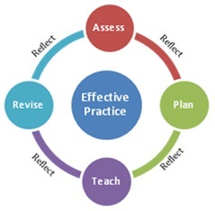
Synthesis of Student Data: Class Profile

Purpose: Creating the Class Profile supports Resident Educators’ understanding of the varied learning needs of each student.
Directions:
- Together, mentors and Resident Educators complete the Class Profile below. List each student’s name and select three data points at the class level to create a data snapshot of the entire class. Some examples of class data include literacy levels, attendance data, authentic assessment results, and discipline data.
- Once the Class Profile has been created, mentors and Resident Educators review it to benchmark student learning levels and to determine instructional grouping.
RESIDENT EDUCATOR CLASS PROFILE
Resident Educator: |  | Date Completed:
Grade Level/Subject Area:
Student Name: | Data Source: | Data Source: | Data Source:
1.
2.
3.
4.
5.
6.
7.
8.
9.
10.
11.
12.
13.
14.
15.
16.
17.
18.
19.
20.

